***Step-by-Step Guide to Start with GitHub***

**1. Go to GitHub Website:**

* Open your browser and navigate to [GitHub](https://github.com).

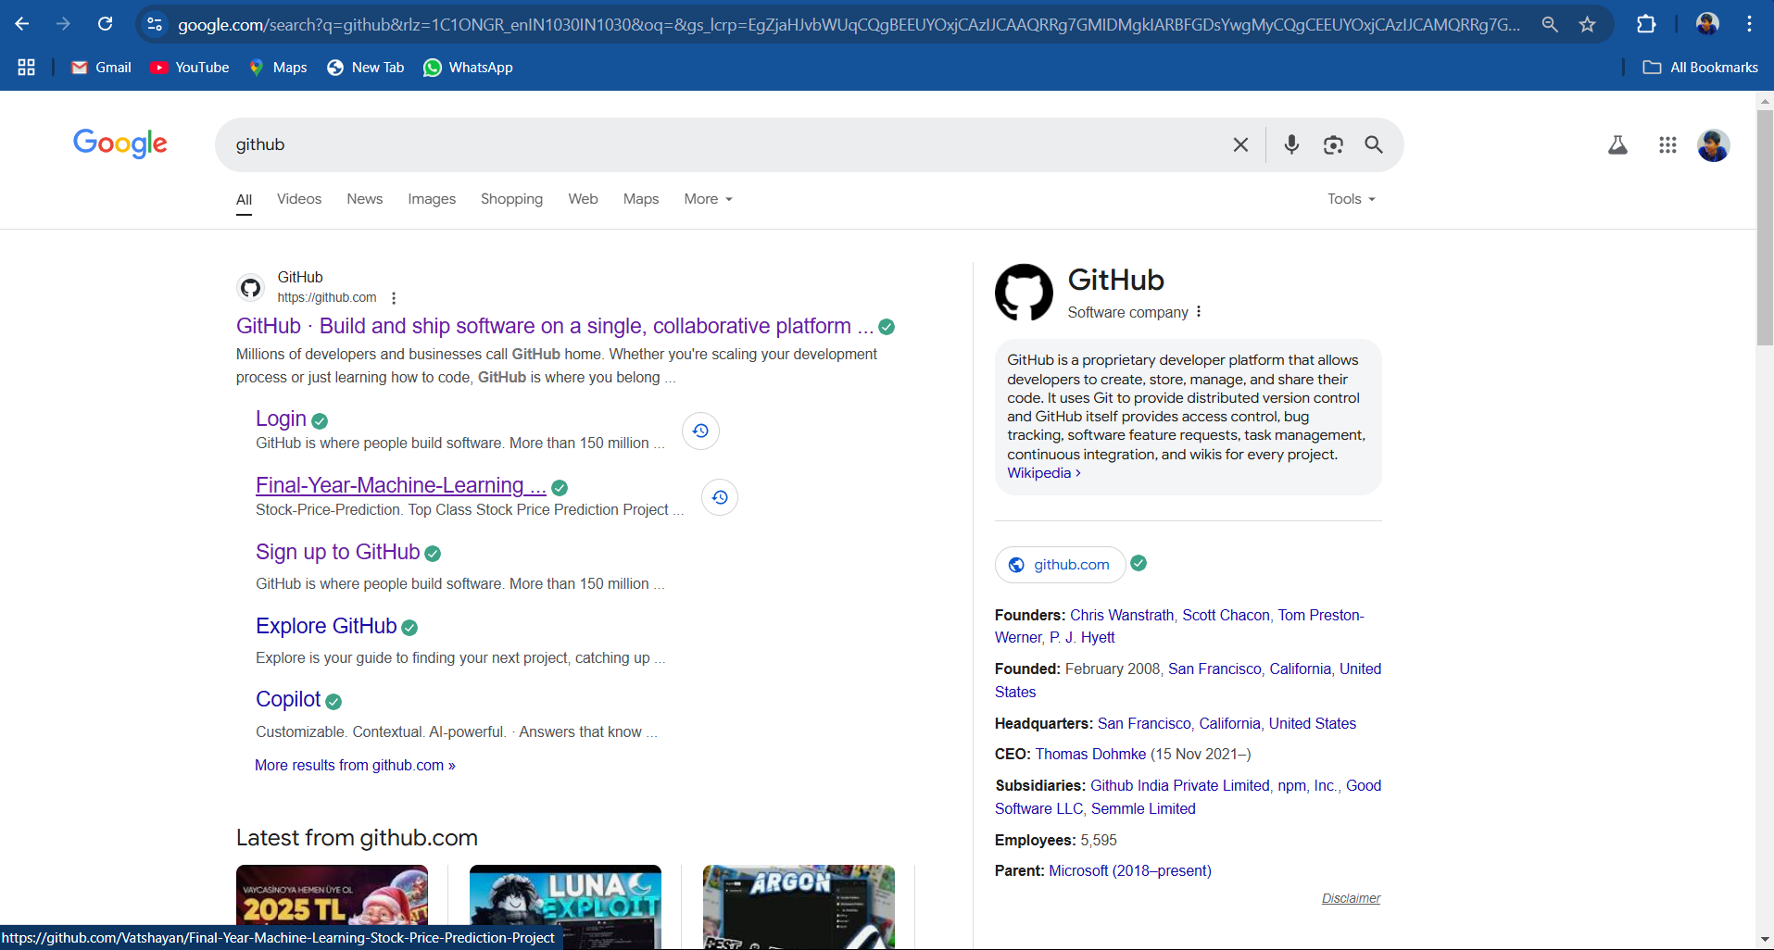

**2. Log in to Your GitHub Account:**

* If you already have a GitHub account:
* Click on the **"Sign in"** button in the top-right corner.
* Enter your **username or email address** and **password** in the login form.
* Click the **"Sign in"**button to access your account.

**3.If you do not have a GitHub account:**

* Click the **"Sign up"** button on the top-right.
* Enter your email address and click **"Continue"**.
* Set a password, username, and verify your email address by following the instructions provided.
* Complete the sign-up process to create a new account.
* 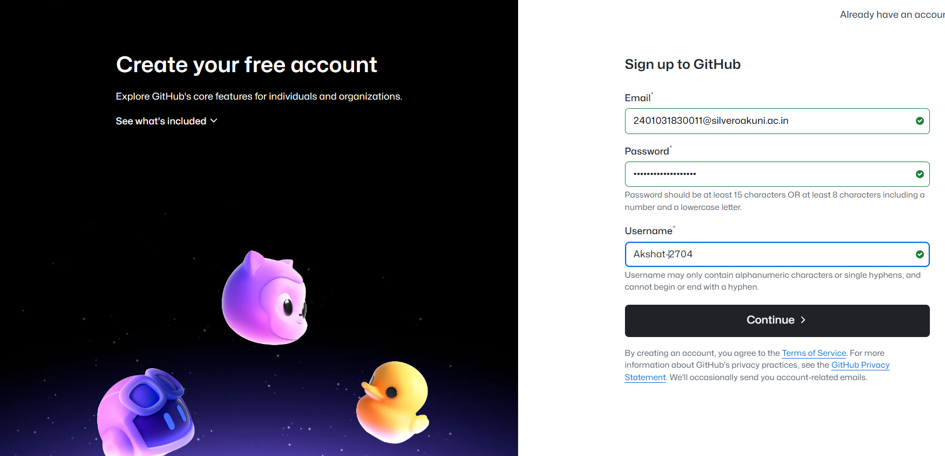

4.Access Your Dashboard

* After logging in, you’ll be redirected to your **GitHub Dashboard**.
* This is your home page, where you can see all your repositories, recent activity, and shortcuts for creating new repositories.

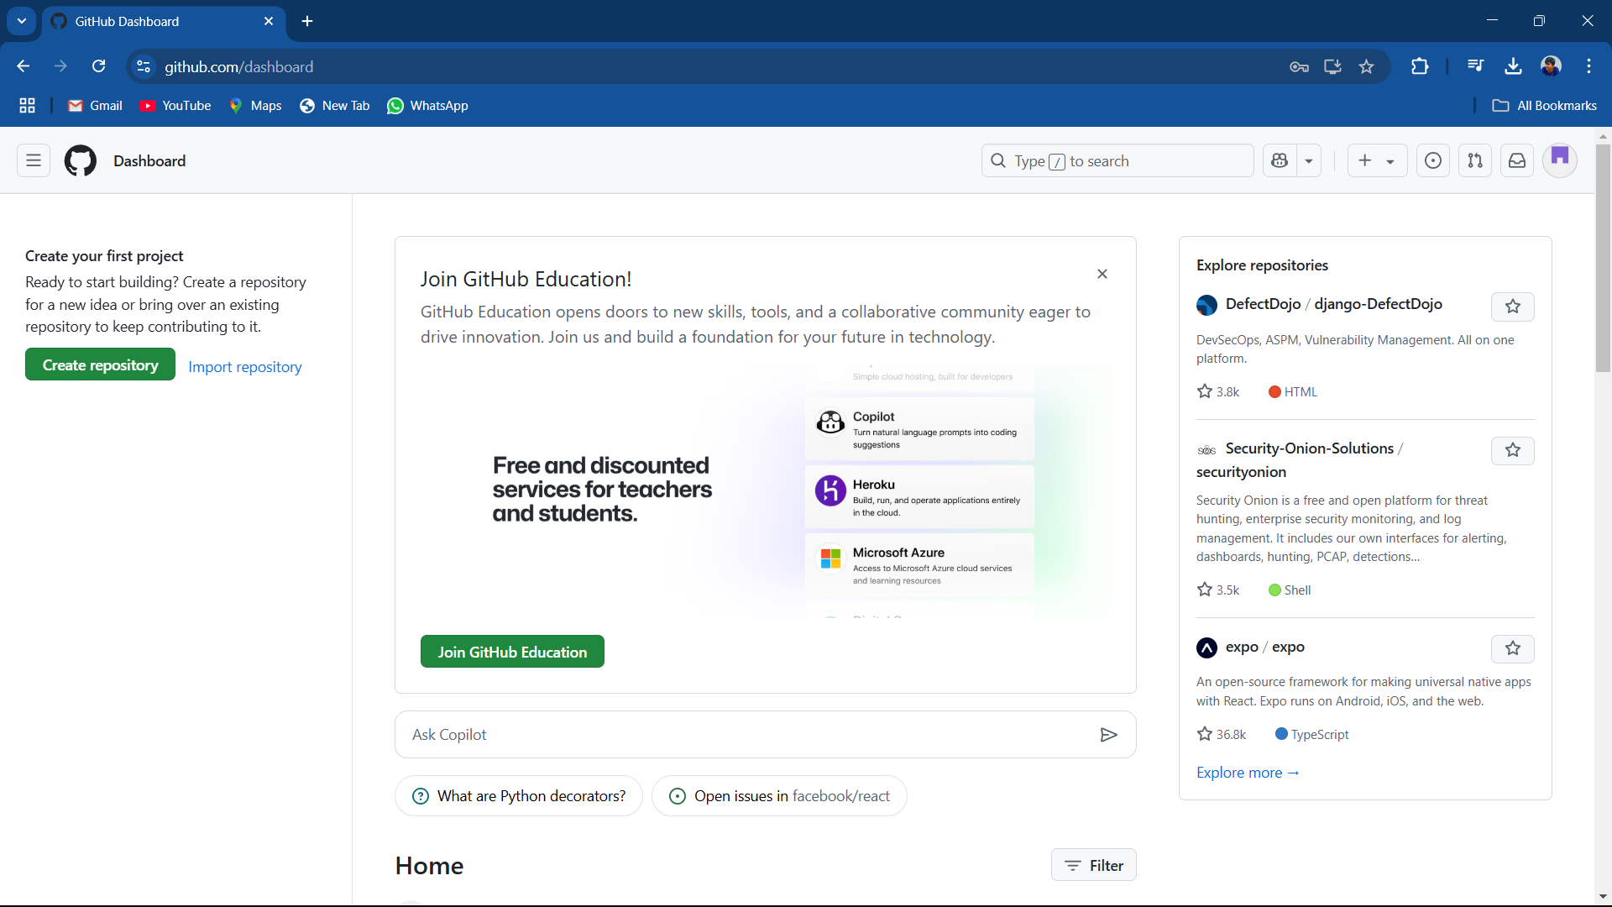

**5.Create a New Repository:**

* From the dashboard, click the green **"New"** button on the left panel or navigate to the **Repositories** tab and select **"New"**.
* Fill out the repository details:
* **Repository Name**: Enter your folder name **(PRJ)**.
* **Privacy**: Choose between:
* **Public** (anyone can see it).
* **Private** (only you and collaborators can access it).
* 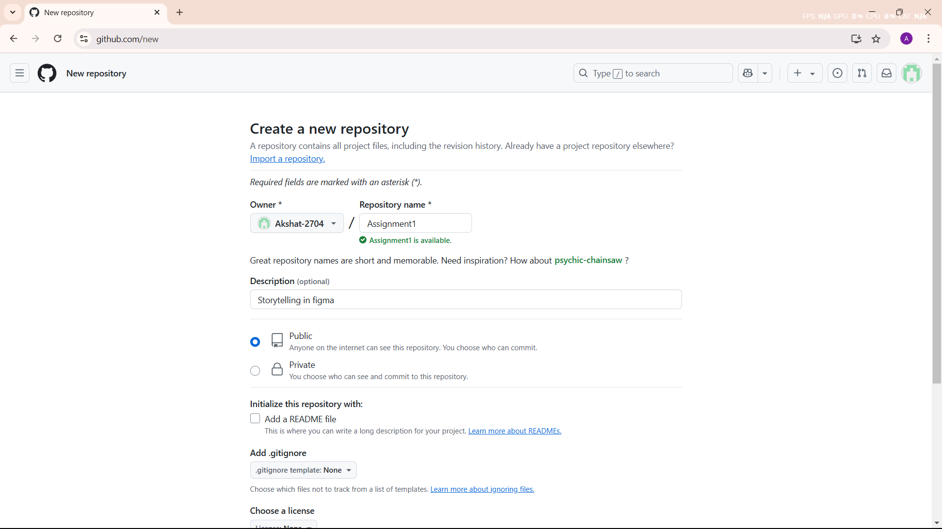

**6.Create the Repository:**

* Click the **"Create repository"** button at the bottom of the page.



**7.Steps for adding a folder:**

**1.Initialize a New Repository**

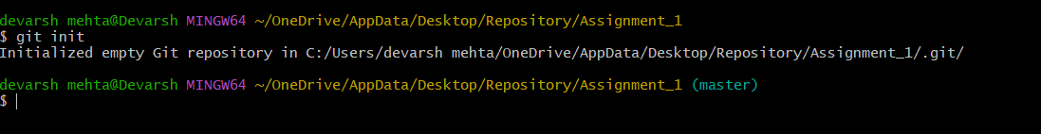

**2.** **Add the File**

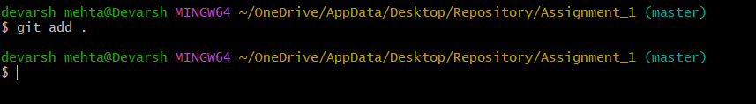

**3.** **Check the status of**

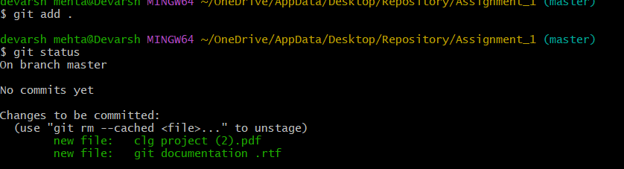

**4.Commit the Changes with a Message**

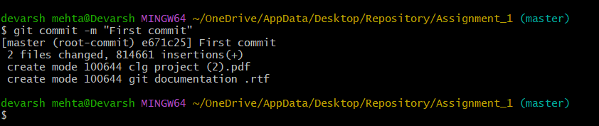

**5.Rename the Branch to master**

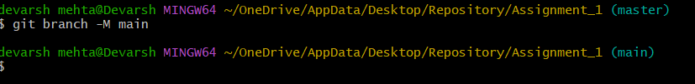

**6.Link the Local Repository to a Remote GitHub Repository**

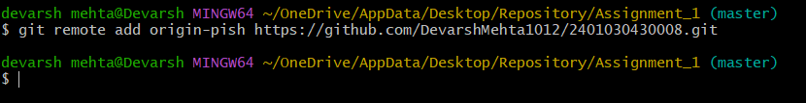

**7.Push the Local Changes to GitHub**

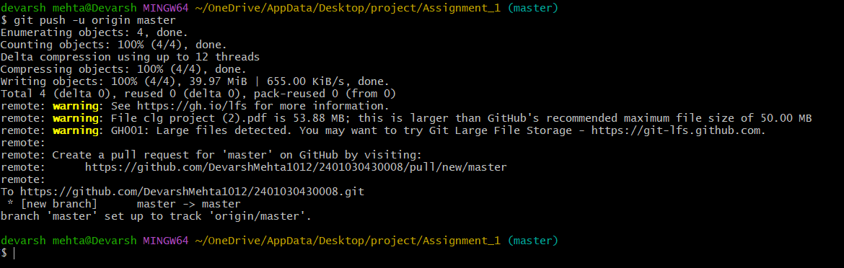

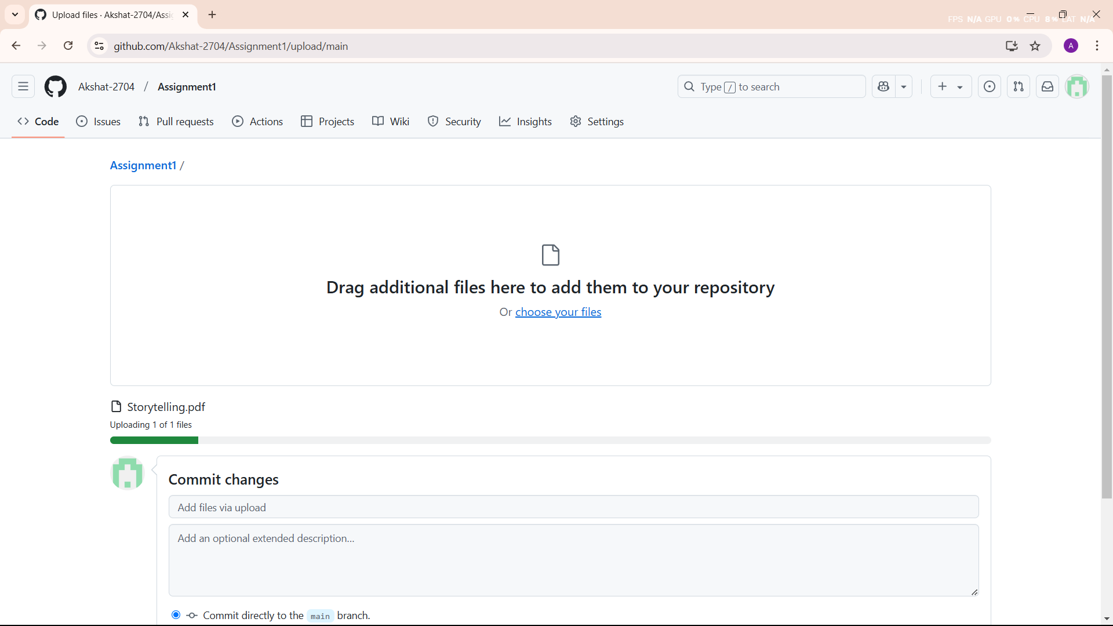**8. Folder are add in repository:**